A History of Fake Carriers
Should you switch to Menace Mobile, which is presented by actor Rob Lowe in a June 2026 TV commercial? Probably not, since Menace Mobile is a fictional carrier mentioned as a bogey in a current Verizon TV ad that is intended to promote Verizon’s new Simplicity Plan.
It turns out that carriers have a long history of contrasting their services with those of fictional carriers that are overpriced and have poor service. A straw man argument is a persuasion technique in which an opponent is sharply discredited, often emotionally, in an effort to make a person or organization seem favorable by comparison.
AllTalk Wireless is a fictional carrier pitched in this “Tiscount” film done by T-Mobile in 2015. The film showed signage for a business plan priced at $90/month and a prospective business customer expressed an interest in the plan. “That’s just the starting point, you haggle from there,” explains a rep.
MegaMobile is a carrier that has its name atop a skyscraper, as portrayed in this “MegaMobile: Deals” TV commercial from Xfinity that has aired in recent months. “Xfinity is now half our price,” said a MegaMobile executive in the video.
Big Wireless is another carrier that has its name on the top of a skyscraper, as seen in this “Dream Job” TV ad from Mint Mobile. The ad aired in 2021 and it featured a character with some serious negatives, Satan.
And then, there’s Claw Mobile. “With Claw Mobile, you get razor-sharp connectivity and ferocious data speeds,” says an actor in this “Claw Mobile” video, which featured a poor man’s version of Hugh Jackman as the Wolverine. The video is from US Mobile and the discount Hugh Jackman takes a swipe at Ryan Reynolds and Mint Mobile in the ad.
Menace Mobile has joined the team. The list of fake carriers now includes Menace Mobile, AllTalk Wireless, MegaMobile, Big Wireless, and Claw Mobile.
And what about PayMore? Well, PayMore is real, but the company is a retailer that buys and sells used electronics via its 50+ retail locations, as seen here. The company is not known to be competing as a wireless carrier or MVNO. “PayMore is a national retail franchise offering buying, selling, and trading of electronics,” the retailer states on its LinkedIn profile.
A PayMore franchisee operating 13 locations is Paul Kushnir, former CEO of Wireless Lifestyle, a Sprint dealer that had ~150 locations. If PayMore ever launches an MVNO, Wave7 Research will report this with joy.
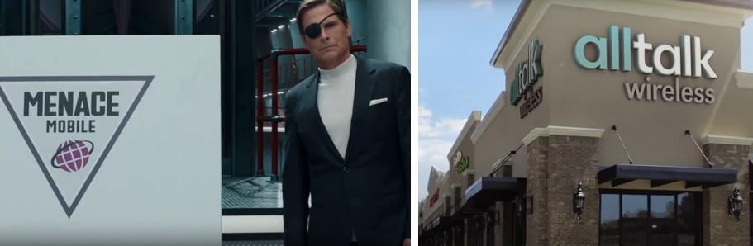
Left: Actor Rob Lowe presents Menace Mobile in June 2026 Verizon TV ad; right: AllTalk Wireless is presented in 2015 T-Mobile video

